# Exercise: Advanced Functions

Problems for exercises and homework for the ["JavaScript Advanced" course @ SoftUni](https://softuni.bg/courses/js-advanced). Submit your solutions in the SoftUni judge system at [https://judge.softuni.bg/Contests/2765/Advanced-Functions-Exercise](https://judge.softuni.bg/Contests/Compete/Index/2765#0)

## Sort Array

Write a function that **sorts an array** with **numeric** values in **ascending** or **descending** order, depending on an **argument** that is passed to it.

You will receive a **numeric array** and a **string** as arguments to the first function in your code.

* If the second argument is asc, the array should be sorted in **ascending order** (smallest values first).
* If it is desc, the array should be sorted in **descending order** (largest first).

### Input

You will receive a **numeric array** and a **string** as input parameters.

### Output

The output should be the **sorted array**.

### Examples

|  |  |
| --- | --- |
| Input | Output |
| [14, 7, 17, 6, 8], 'asc' | [6, 7, 8, 14, 17] |
| [14, 7, 17, 6, 8], 'desc' | [17, 14, 8, 7, 6] |

## Argument Info

Write a function that displays **information** about the **arguments** which are passed to it (**type** and **value**) and a **summary** about the number of each type in the following format:

"{argument type}: {argument value}"

Print **each** argument description on a **new line**. At the end print a **tally** with counts for each type in **descending order**, each on a **new line** in the following format:

"{type} = {count}"

If two types have the **same count**, use **order of appearance**.

Do **NOT** print anything for types that do not appear in the list of arguments.

### Input

You will receive a series of arguments **passed** to your function.

### Output

**Print on the console** the **type** and **value** of each argument passed into your function.

### Example

|  |
| --- |
| Input |
| 'cat', 42, function () { console.log('Hello world!'); } |
| Output |
| string: cat  number: 42  function: function () { console.log('Hello world!'); }  string = 1  number = 1  function = 1 |

## Fibonacci

Write a JS function that when called, returns the next Fibonacci number, starting at 0, 1. Use a **closure** to keep the current number.

### Input

There will be no input.

### Output

The **output** must be a Fibonacci number and must be **returned** from the function.

### Examples

|  |
| --- |
| Sample exectuion |
| let fib = getFibonator();  console.log(fib()); *// 1*  console.log(fib()); *// 1*  console.log(fib()); *// 2*  console.log(fib()); *// 3*  console.log(fib()); *// 5*  console.log(fib()); *// 8*  console.log(fib()); *// 13* |

## Breakfast Robot

Your task is to write the management software for a breakfast chef robot - it needs to **take orders**, keep track of available **ingredients** and output an **error** if something’s wrong. The cooking instructions have already been installed, so your module needs to **plug into** the system and only take care of **orders** and **ingredients**. And since this is the future and food is printed with nano-particle beams, all ingredients are microelements - **protein**, **carbohydrates**, **fat** and **flavours**. The library of recipes includes the following meals:

* Apple - made with **1 carb** and **2 flavour**
* Lemonade - made with **10 carb** and **20 flavour**
* Burger - made with **5 carb**, **7 fat** and **3 flavour**
* Eggs - made with **5 protein**, **1 fat** and **1 flavour**
* Turkey - made with **10 protein**, **10 carb**, **10 fat** and **10 flavour**

The robot receives instructions either to **restock** the supply, **cook** a meal or **report** statistics. The input consists of one of the following commands:

* restock <microelement> <quantity> - increases the stored quantity of the given microelement
* prepare <recipe> <quantity> - uses the available ingredients to prepare the given meal
* report - returns information about the stored microelements, in the order described below, including zero elements

The robot is equipped with a quantum field storage, so it can hold an **unlimited quantity** of ingredients, but there is no guarantee there will be enough available to prepare a recipe, in which case an **error message** should be returned. Their availability is checked in the **order** in which they **appear** in the recipe, so the error should reflect the first requirement that was not met.

Submit a **closure** that returns the management function. The management function takes one parameter.

### Input

Instructions are passed as a **string argument** to your management function. It will be called **several times** per session, so internal state must be **preserved** throughout the entire session.

### Output

The **return** value of each operation is one of the following strings:

* Success - when restocking or completing cooking without errors
* Error: not enough <ingredient> in stock - when the robot couldn’t muster enough microelements
* protein={qty} carbohydrate={qty} fat={qty} flavour={qty} - when a report is requested, in a single string

### Constraints

* Recipes and ingredients in commands will always have valid names.

### Examples

|  |
| --- |
| Execution |
| let manager = solution();  manager("restock flavour 50"); *// Success*  manager("prepare lemonade 4"); *// Error: not enough carbohydrate in stock* |

|  |  |
| --- | --- |
| Input | Output |
| restock carbohydrate 10  restock flavour 10  prepare apple 1  restock fat 10  prepare burger 1  report | Success  Success  Success  Success  Success  **protein=0** carbohydrate**=4** fat**=3** flavour**=5** |

|  |  |
| --- | --- |
| Input | Output |
| prepare turkey 1  restock protein 10  prepare turkey 1  restock carbohydrate 10  prepare turkey 1  restock fat 10  prepare turkey 1  restock flavour 10  prepare turkey 1  report | Error: not enough protein in stock  Success  Error: not enough carbohydrate in stock  Success  Error: not enough fat in stock  Success  Error: not enough flavour in stock  Success  Success  **protein=0** carbohydrate**=0** fat**=0** flavour**=0** |

**Environment Specifics**

Please, be aware that every JS environment may **behave differently** when executing code. Certain things that work in the browser are not supported in **Node.js**, which is the environment used by **Judge**.

The following actions are **NOT** supported:

* **.forEach()** with **NodeList** (returned by **querySelector()** and **querySelectorAll()**)
* **.forEach()** with **HTMLCollection** (returned by **getElementsByClassName()** and **element.children**)
* Using the **spread-operator** (**...**) to convert a **NodeList** into an array

If you want to perform these operations, you may use **Array.from()** to first convert the collection into an array.

## Functional Sum

Write a function that **adds** a number passed to it to an **internal sum** and returns **itself** with its internal sum set to the **new value**, so it can be **chained** in a functional manner.

### Input

Your function needs to take one **numeric** **argument**.

### Output

Your function needs to **return** itself with an updated context.

### Example

|  |  |
| --- | --- |
| Input | Output |
| add(1) | 1 |
| add(1)(6)(-3) | 4 |

## Monkey Patcher *

Your employer placed you in charge of an old forum management project. The client requests new functionality, but the legacy code has high coupling, so you don’t want to change anything, for fear of breaking everything else. You know which values need to be accessed and modified, so it’s time to monkey patch!

Write a program to extend a forum post record with voting functionality. It needs to have the options to **upvote**, **downvote** and tally the **total** **score** (positive minus negative votes). Furthermore, to prevent abuse, if a post has more than 50 **total** **votes**, the numbers must be obfuscated – the stored values remains the same, but the **reported** amounts of upvotes and downvotes have a number **added** to them. This number is 25% of the **greater number** of votes (positive or negative), rounded up. The actual numbers should **not be modified**, just the reported amounts.

Every post also has a **rating**, depending on its score. If **positive** votes are the overwhelming majority (>66%), the rating is hot. If there is no majority, but the balance is non-negative and **either** votes are more than 100, its rating is controversial. If the balance is negative, the rating becomes unpopular. If the post has less than 10 **total** votes, or no other rating is met, it’s rating is new regardless of balance. These calculations are performed on the actual numbers.

Your function will be invoked with call(object, arguments), so treat it as though it is internal for the object. A forum post, to which the function will be attached, has the following structure:

|  |
| --- |
| JavaScript |
| {  id: <id>,  author: <author name>,  content: <text>,  upvotes: <number>,  downvotes: <number>  } |

The arguments will be one of the following strings:

* upvote – increase the positive votes by one
* downvote – increase the negative votes by one
* score – report positive and negative votes, balance and rating, in an array; obfuscation rules apply

### Input

Input will be passed as arguments to your function through a call() invocation.

### Output

Output from the report command should be **returned** as a result of the function in the form of an **array** of three **numbers** and a **string**, as described above.

### Examples

|  |
| --- |
| Sample execution |
| let post = {  id: '3',  author: 'emil',  content: 'wazaaaaa',  upvotes: 100,  downvotes: 100  };  solution.call(post, 'upvote');  solution.call(post, 'downvote');  let score = solution.call(post, 'score'); *// [127, 127, 0, 'controversial']*  solution.call(post, 'downvote'); … *// (executed 50 times)*  score = solution.call(post, 'score'); *// [139, 189, -50, 'unpopular']* |
| Explanation |
| The post begins at 100/100, we add one upvote and one downvote, bringing it to 101/101. The reported score is inflated by 25% of the greater value, rounded up (26). The balance is 0, and at least one of the numbers is greater than 100, so we return an array with rating 'controversial'.  We downvote 50 times, bringing the score to 101/151, the reported values are inflated by 151*0.25=38 (rounded up) and since the balance is negative with return an array with rating 'unpopular'. |

# DOM-Related Problems

The following problems must be solved using DOM manipulation techniques.

## Simple Calculator

Create a function which returns an object that can modify the DOM. The returned object should support the following functionality:

* init(selector1, selector2, resultSelector) - initializes the object to work with the elements corresponding to the supplied selectors.
* add() - **adds** the numerical value of the element corresponding to selector1 to the numerical value of the element corresponding to selector2 and then writes the result in the element corresponding to **resultSelector**
* subtract() - **subtracts** the numerical value of the element corresponding to selector2 from the numerical value of the element corresponding to selector1 and then writes the result in the element corresponding to resultSelector

### Input

There will be no input your function must only provide an object.

### Output

Your function should return an object that meets the specified requirements.

### Constraints

* **All commands will always be valid, there will be no nonexistent or incorrect input.**
* **All selectors will point to single textbox elements.**

### HTML

You are given the following HTML for testing purposes:

|  |  |
| --- | --- |
| sum.html | |
| <!DOCTYPE **html**>  <**html** **lang=**"**en**">  <**head**>  <**meta** **charset=**"**UTF-8**">  **<link rel="stylesheet" href="style.css">**  <**title**>Title</**title**>  </**head**>  <**body**>  <**div** **class="container"**>  <**h1** **class="title"**>Simple Calculator</**h1**>  <**p**>Enter two numbers</**p**><**br**>  <**div** **class="input">**  <**label** **for="num1">**Number-1</**label**> <**br**>  <**input** **type="text"** **id="num1"**> <**br**>  <**label** **for="num2"**>Number-2</**label**> <**br**>  <**input** **type="text"** **id="num2"**> <**br**>  <**hr**>  <**label** **for="result"**>Result is</**label**> <**br**>  <**input** **type="text"** **id="result"** readonly /><**br**>  </**div**>  <**br**>  <**button** **id="sumButton"**>Sum</**button**>  <**button** **id="subtractButton"**>Subtract</**button**>  </**div**>  </**body**>  </**html**> | |
| Simple-Calculator.css | |
| **body** {  background-color: #ccc;  color: white;  }  .**container** {  margin: 0 auto;  margin-top: 50px;  border-radius: 10px;  width: 400px;  background-color: #303333;  text-align: center;  border: solid 2px #3786c7;  }  **.container p** {  font-size: 20px;  }  **.title** {  color: #02e063;  }  **#sumButton** {  margin-bottom: 20px;  } | |

## Next Article

Write a JS program that sequentially **displays articles** on a web page when the user **clicks** a button. You will receive an **array of strings** that will initialize the program. You need to return a function that keeps the initial array in its closure and every time it’s called, it takes the first element from the array and displays it on the web page, inside a div with ID "**content**". If there are no more elements left, your function should do nothing.

Your function will be called automatically, there is **no need** to attach any event listeners.

### Input

You will receive and **array** of strings.

### Output

Return a **function** that displays the array elements on the web page.

### Examples

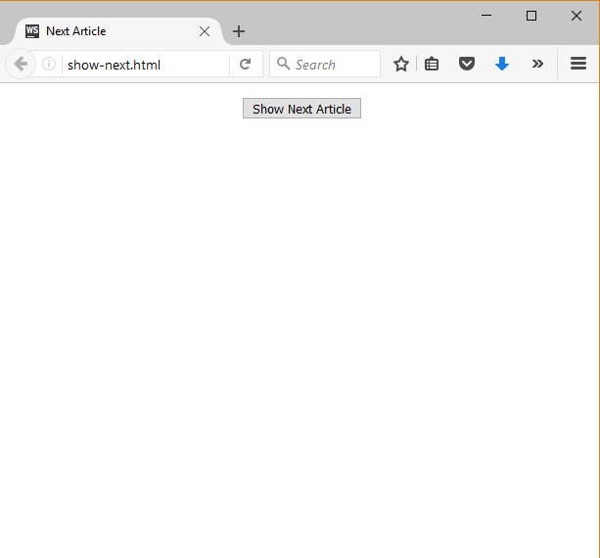 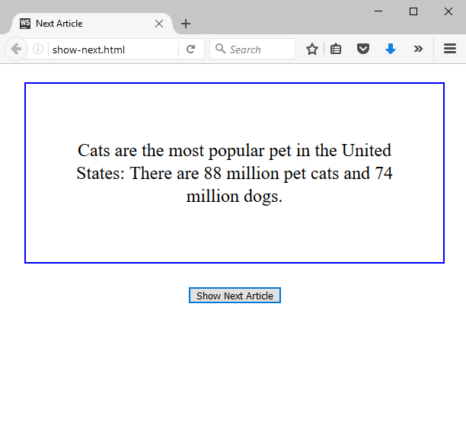 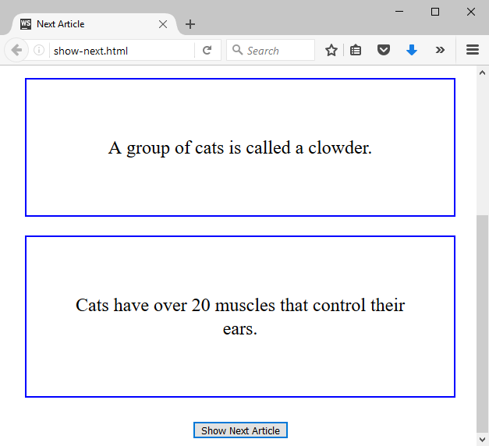

## Central Cinema

### Use the given skeleton to solve this problem.

### Note: You have NO permission to change directly the given HTML *(index.html file)*.

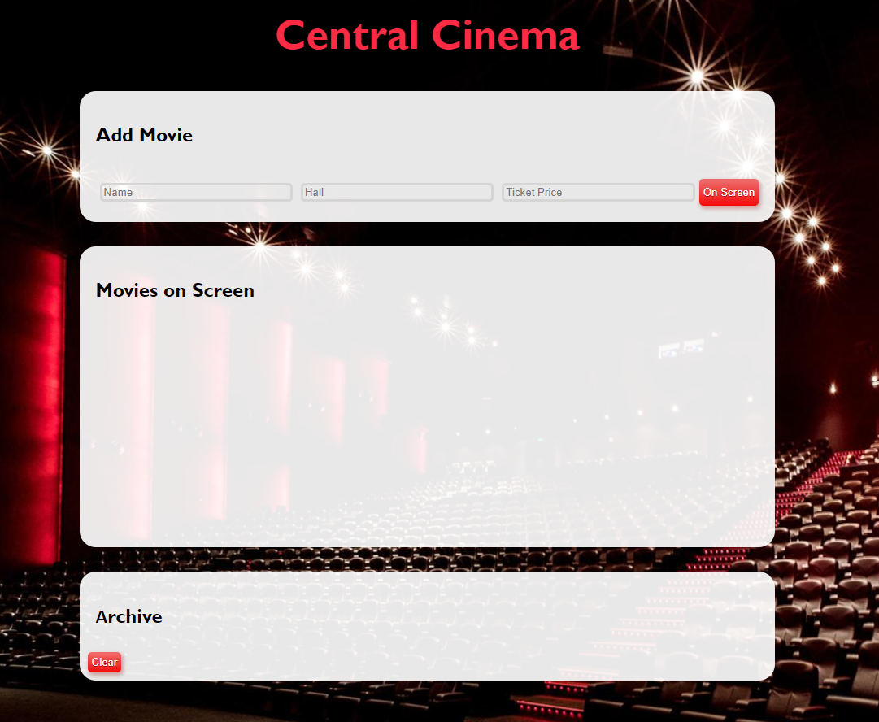

### Your Task

Write the missing JavaScript code to make the Central Cinema application work as expected.

Each movie have **Name**, **Hall** and **Ticket** **Price**.

When you click the **[On Screen]** button and **only** if **inputs** are all **filled** and the ticket **price value** is a **number**, then a new **list item** should be added to the **Movies on Screen** section. Clear the inputs.

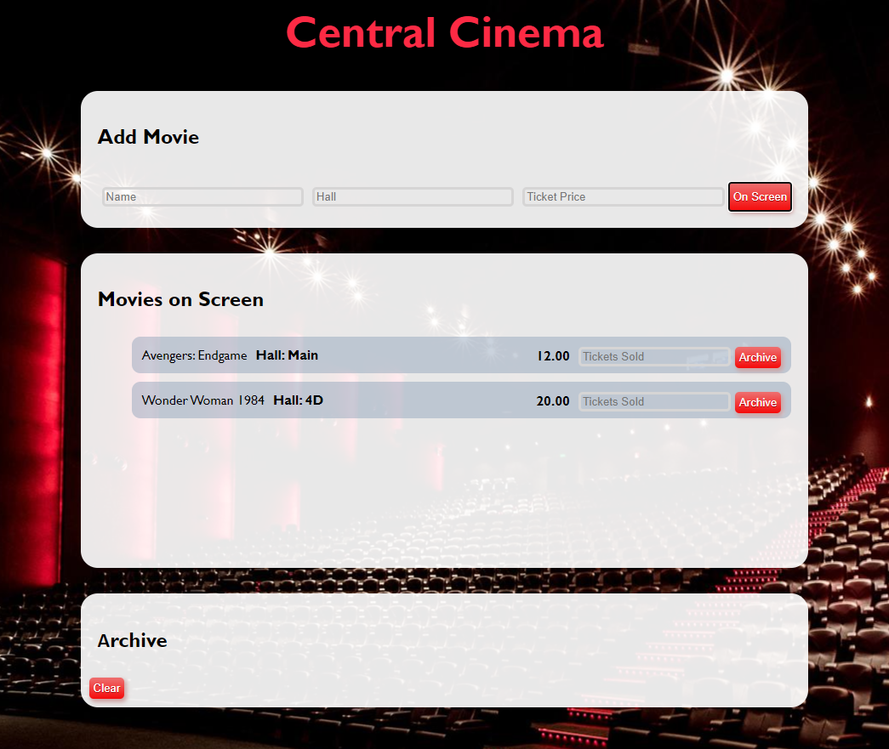

The new item should have the **following structure**:

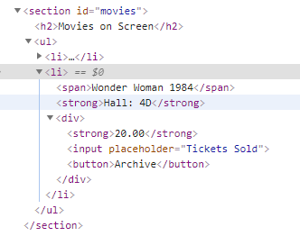

You should create a **li** element that contains **span** element with the name of the movie, a **strong** element with the name of the hall like **“Hall: { hallName }“** and a **div** element. Inside the **div** element, there are a **strong** element with the ticket price, **input** element with **placeholder** containing **“Tickets Sold”** and a button **[Archive]**.

When you click the **[Archive]** button and **only** if the input for tickets count is **filled with a number** like:

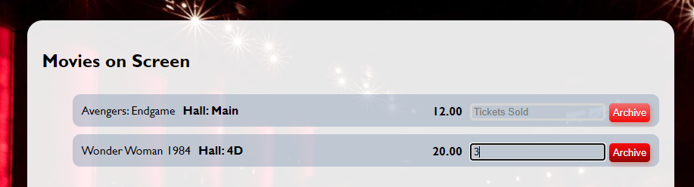

You should **add** that item to **Archive** section like a list item in the **ul,** calculating the total profit of the movie like this:

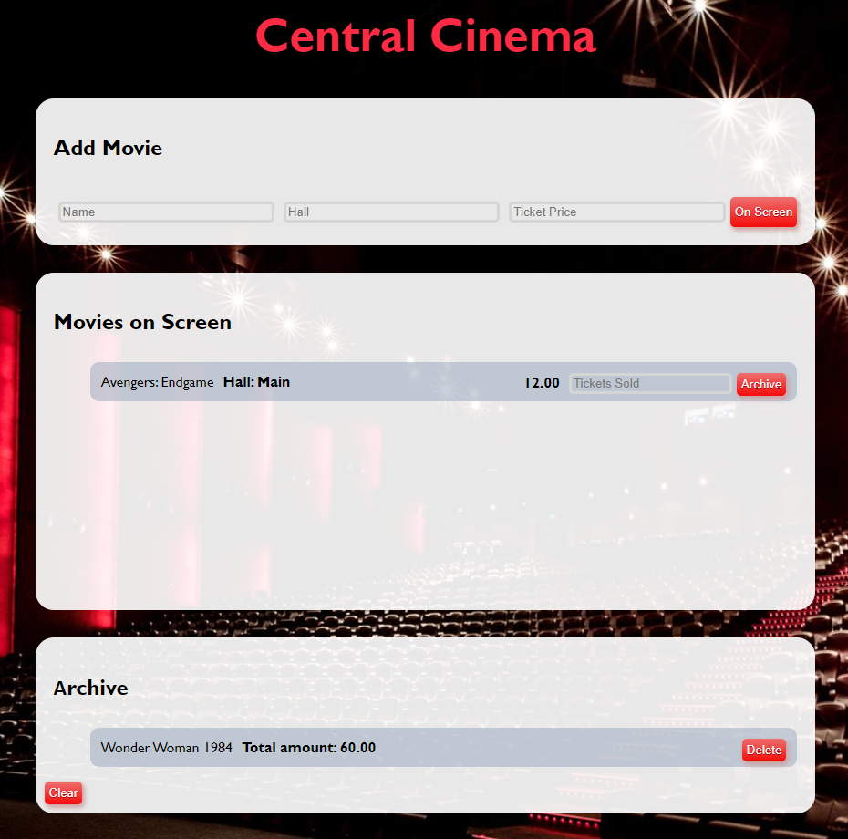

Use the following format:

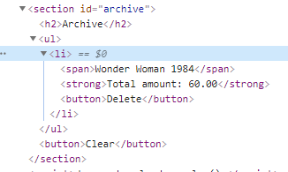

Here we have **list item** containing **span** element with the name of the movie, **strong** element with total profit like “**Total amount: {total price}**” **fixed to the second digit** after the decimal point. Add a delete button **[Delete]**.

When you click the **[Delete]** button, you should **delete the current list item.**

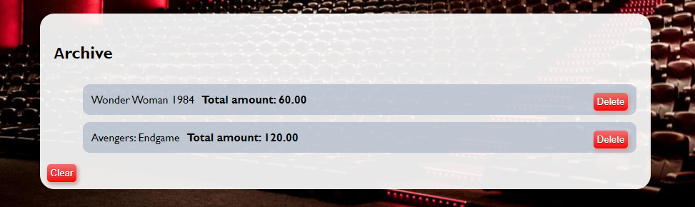

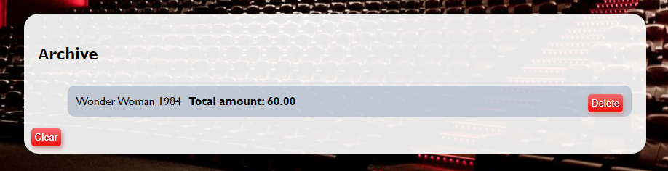

Finally, when we click the **[Clear]** button **delete** all **li** elements from the **archive** section. No matter how many archived movies we have the archive section leaves like this:

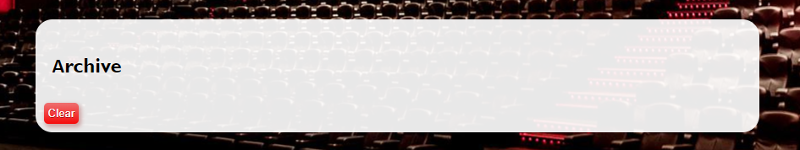

## Task Manager *

Use the **index.html** and **app.js** files to solve this problem. You have **NO permission** to directly change the given HTML code (index.html file).

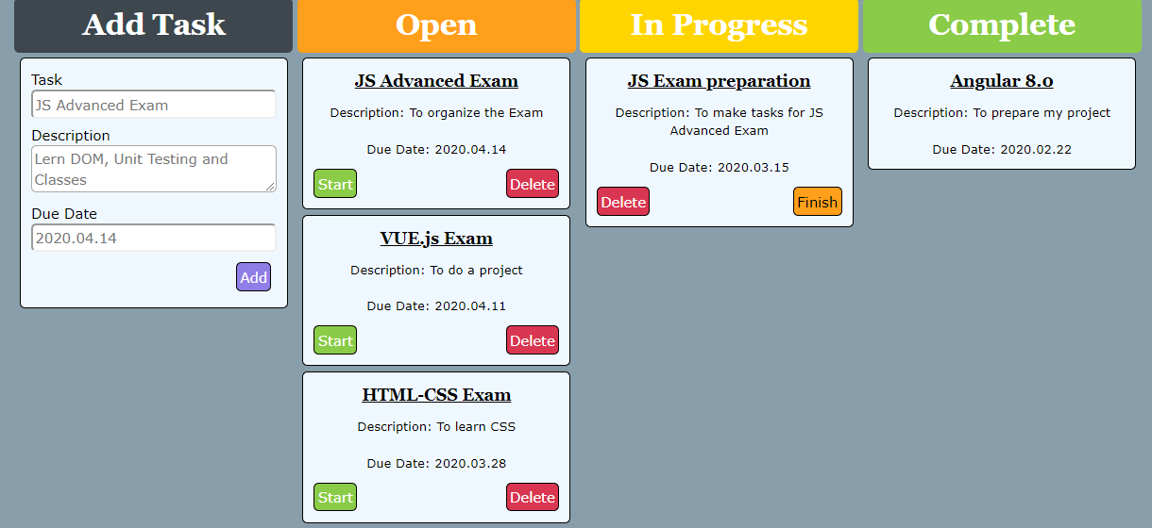

### Your task

**Write the missing JavaScript code** to make the **Task Manager Functionality** works as follows:

When the Add button is clicked, first you need to validate the inputs. If any of the input fields is empty, the function doesn’t make anything.

After validating the input fields, you need to add the new task (article) in “Open” section.

The HTML structure looks like this:

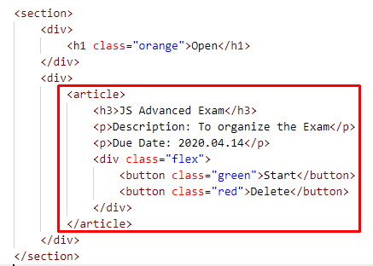

The article should have two buttons “Start” and “Delete”. Be careful to set the classes for the buttons and the parent-div.

When the “Start” button is clicked, you need to move the Task in the section “In Progress”. Be careful with the buttons! The HTML structure looks like this:

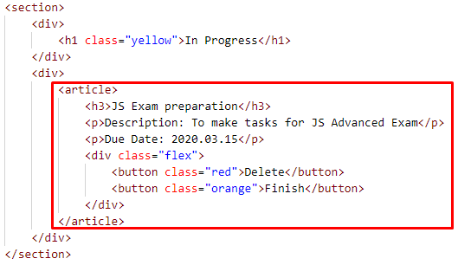

When the “Delete” button is clicked, the Task (whole article) should be removed from the HTML.

After clicking the “Finish” button, the Task will be completed, and you should move the article in the section “Complete”. The buttons with their parent div-element should be removed.

